

SARAS - IIS Configuration

# IIS intallation

* Press the [Windows] key and select Server Manager.

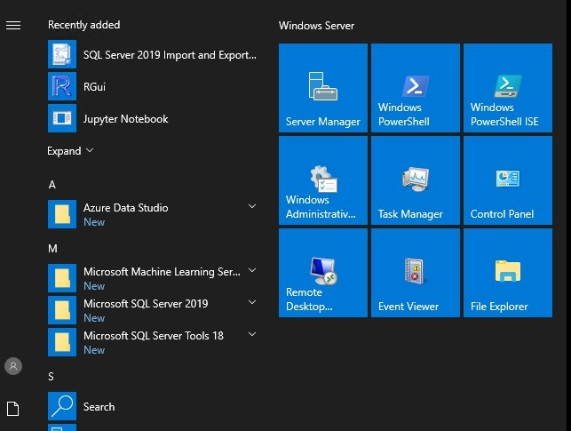

* In the Server Manager dashboard, click manage > add roles and features.

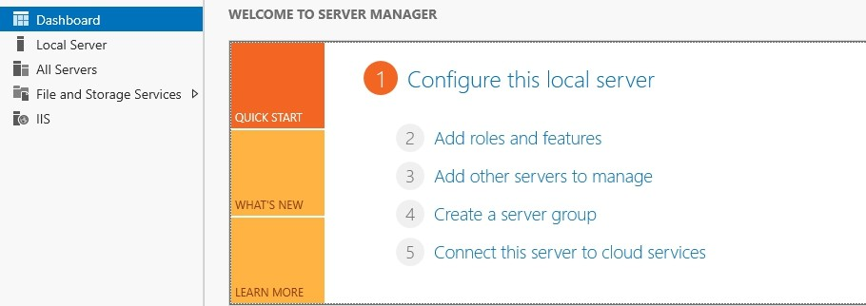

* Click installation type and click next.

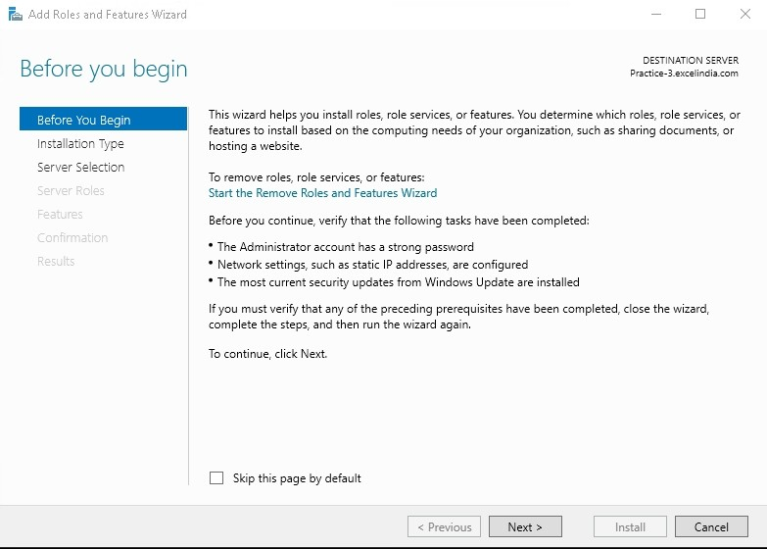

* Select the role-based or feature-based installation option and click Next.

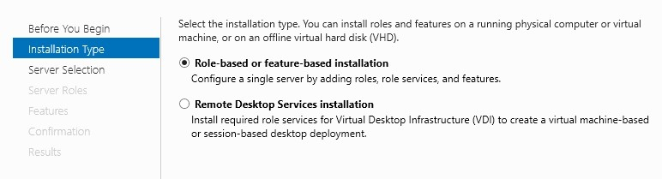

* Select the server on which IIS will be installed and click Next.

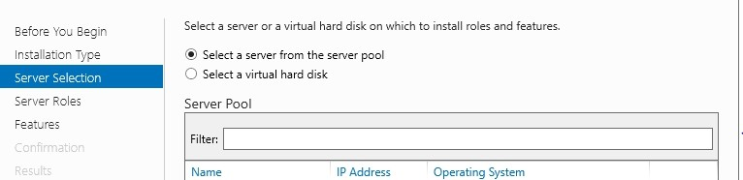

* Activate the Web Server (IIS) Role in server roles and click next.

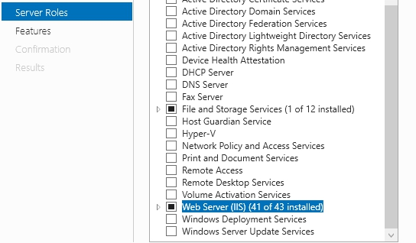

* Select required features.

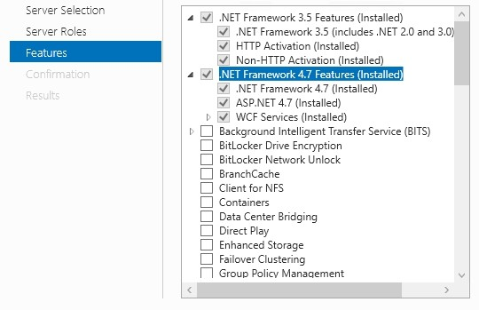

* Select required Web Server Role (IIS)

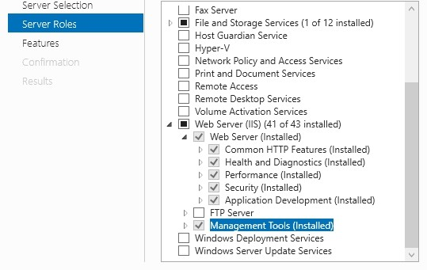

* Click Install to install the selected roles, role services and features.
* Click Close to complete the installation.

# IIS Logs File Settings

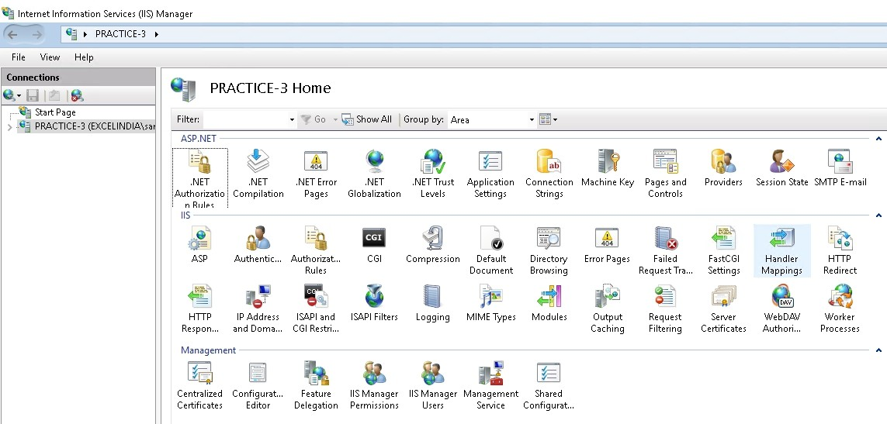

1. Click Start and select Run or “**Windows Button + R**” Type “**inetmgr**” (Internet Information Services Manager) and select ok.

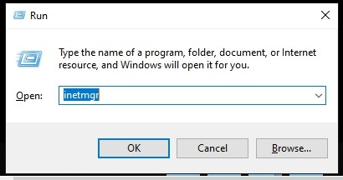

1. After launching the IIS Manger on the **Feature View** Select **Logging**

Option.

1. Click on Select fields and select all the Fields in the logging option.

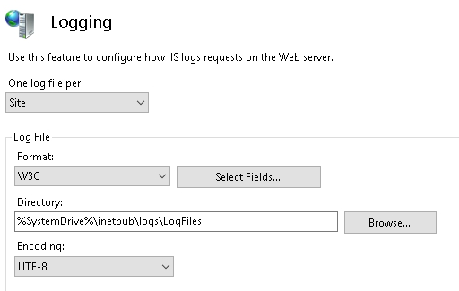

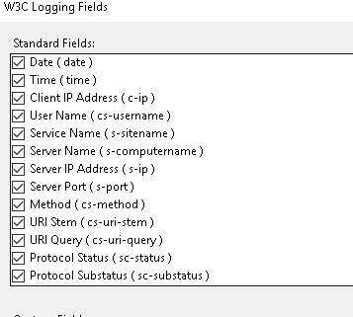

1. Change the IIS logs Directory to move to other drive.

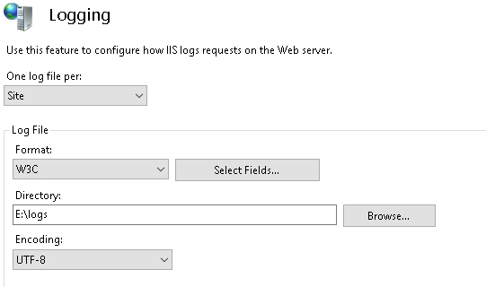

1. Select **Maximum Files size** and Provide **Maximum Files size (in bytes)** 3MB - 3000000 in bytes.

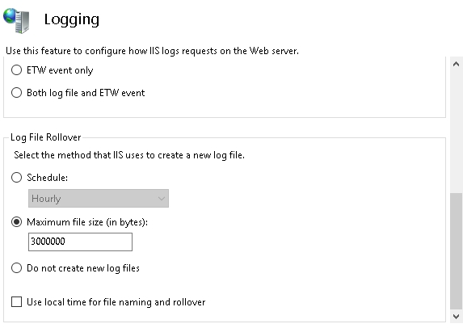

1. Click **Apply** button to save.

